**Tableau Wine Review Analysis Top Countries and Wineries(150k Reviews)**

**Problem Statement:**

The ABC Company endeavors to harness the power of a dataset comprising 150,000 wine reviews, analyzing factors such as wine formula, points, price, review count by country, and total wine prices by winery. Through this comprehensive analysis, the company aims to gain insights into global wine trends, identifying consumer preferences, key markets, and winery performance. By leveraging these insights, ABC Company seeks to make strategic decisions pertaining to product offerings, marketing strategies, and business expansion in the dynamic landscape of the global wine market, ultimately enhancing its competitive edge and catering to the diverse needs of wine enthusiasts and consumers worldwide.



**Prerequisites:**

* Basic understanding of Data Analytics

[What Is Data Analytics? - An Introduction (Full Guide)](https://youtu.be/yZvFH7B6gKI?si=jD37tQzKJH1vl56A)

* Awareness of the lifecycle of a Data Analytics Project

[A Beginners Guide To The Data Analysis Process](https://youtu.be/lgCNTuLBMK4?si=a_J79oNSQIGNuNlH)

* Understand Tableau Interface- [Link](https://www.youtube.com/watch?v=oIw8xJ1Fy3w)
* Download Tableau Desktop-[Link](https://www.tableau.com/products/desktop/download)

**Objective:**

An objective is a specific, measurable, and time-bound goal or target that an individual or organization aims to achieve. Objectives are typically set to guide actions and decision-making towards desired outcomes. They are often a part of broader goals and help to clarify what needs to be accomplished within a certain timeframe. Objectives should be realistic, achievable, and relevant to the overall mission or purpose, providing a clear direction for efforts and resources.

**Task:**

* Extract valuable insights from a dataset of 150,000 wine reviews to understand consumer preferences regarding wine formulas, points, and prices, aiding in product development and marketing strategies.
* Identify key markets by analyzing review counts by country, enabling targeted marketing efforts and resource allocation to regions with high wine consumption and demand.
* Assess the performance of wineries based on total wine prices, facilitating strategic partnerships and optimization of product portfolios to maximize profitability.

**Dataset**: [Link](https://www.kaggle.com/datasets/zynicide/wine-reviews)

**Solution Development Procedure:**

* In Tableau, the "Connect" option refers to the initial step in the data visualization process where users connect to various data sources to import data into Tableau for analysis and visualization.

* When you select the "Connect" option in Tableau, you are presented with a variety of data connection options.

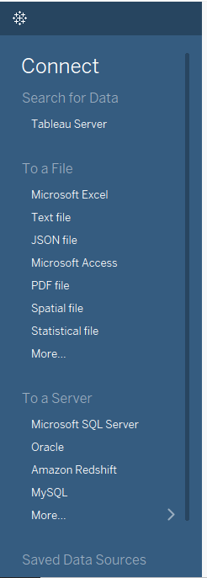

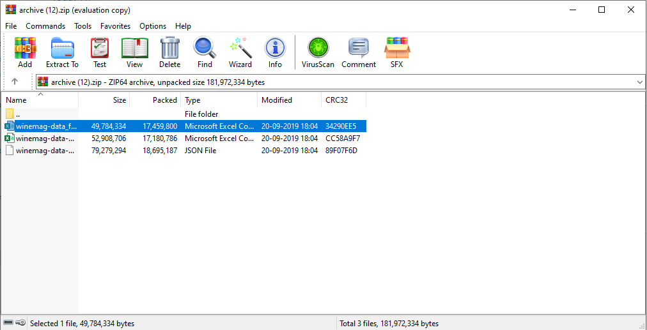

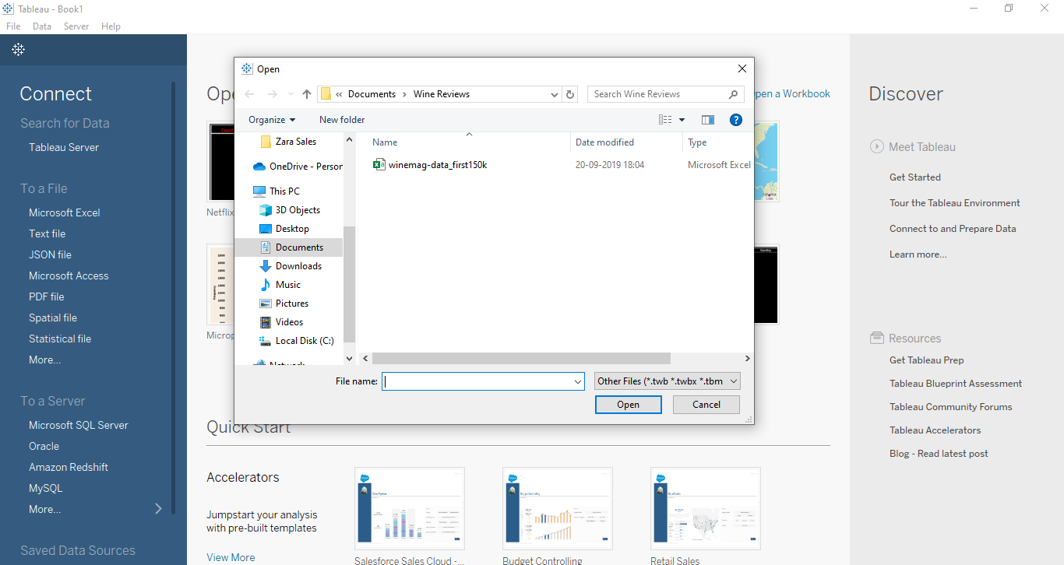

* Once we load the data into the Tableau.

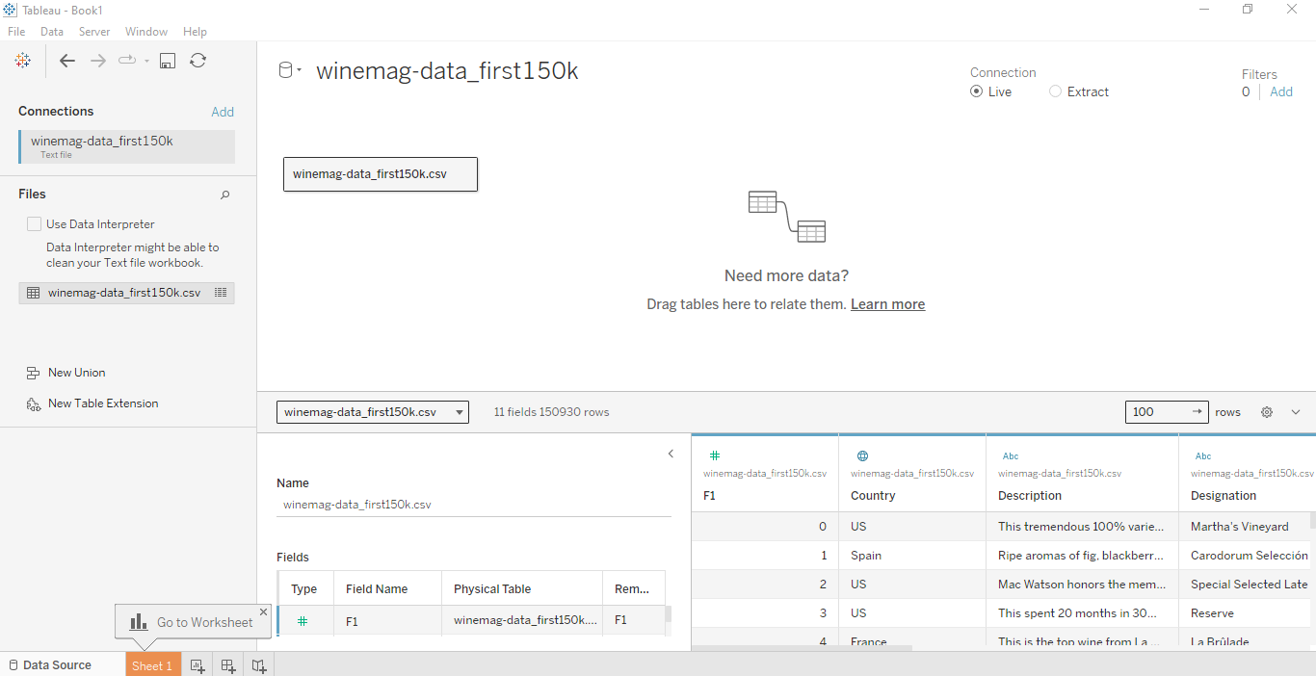

* Now , we proceed to create dashboard for Wne Price Insights (150k Reviews).
* To create the dashboard, which will satisfy the task above, we consider the followingcolumns:
  + Count of 150k Wine Reviews by Country
  + Total Wine Prices by Winery
  + First 150k Wine Reviews
  + Total Formula (F1)
  + Total Points
  + Total Price
* We have created the dashboard which is presented below.

**Dashboard:**

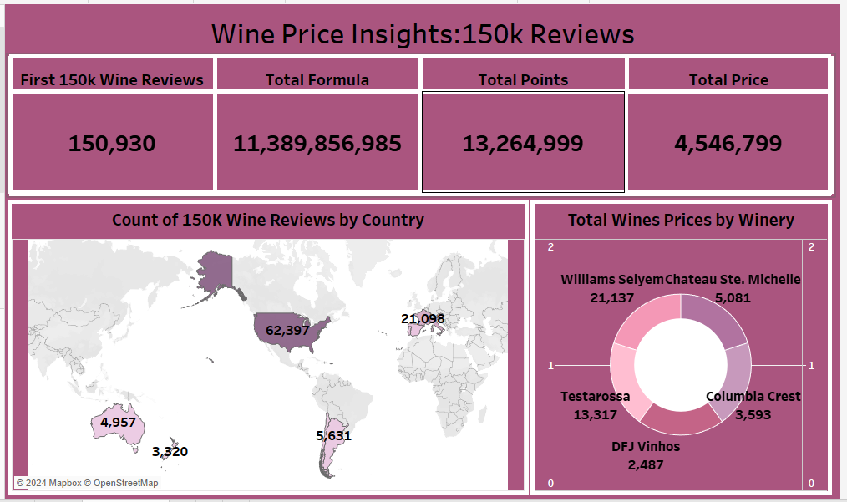

**Explanation Video:** Link

Note: The explanation video for the dashboard is in the link above.

**Insights:**

Insights refer to valuable and meaningful understandings or perceptions gained from analysing data, information, or experiences. They provide deeper understanding, clarity, or revelation regarding a particular subject or situation.

* The geographical distribution of wine reviews shows a significant concentration in Europe and North America. Europe, in particular, has a substantial number of reviews.
* Among the listed wineries, Williams Selyem stands out with the highest total wine prices (21,137). Investigating the factors contributing to their premium pricing could provide valuable insights.
* The relationship between the total formula (11,389,856,985) and total points (13,264,999) is essential. Analyzing this correlation could reveal patterns related to wine quality and critical acclaim.

**Conclusions :**

Conclusions are logical deductions or decisions drawn from observations, evidence, or analysis. Conclusions are often based on the findings or results of a study, experiment, or evaluation, and they aim to summarize key insights or outcomes. Effective conclusions should be supported by evidence, logical reasoning, and critical thinking, leading to well-informed decisions or actions.

* The analysis of 150,000 wine reviews has provided valuable insights into global wine trends, highlighting consumer preferences for specific wine formulas, point ratings, and price ranges.
* By identifying key markets and assessing winery performance, businesses can strategically position themselves to capitalize on opportunities in the dynamic wine industry, tailoring their offerings to meet consumer demand effectively.
* This comprehensive understanding of consumer behavior and market dynamics enables businesses to make informed decisions, driving product development, marketing strategies, and partnerships to enhance competitiveness and profitability in the global wine market.